FABRICATION OF PUNCHING AND SLOTTING MACHINE
ABSTRACT
Now a day, Machines are widely controlled by embedded system. To meet the need of exploding population economic and effective control of machines is necessary.
Our project punching of letter is done by pneumatic operation and eliminates the accident during operation. It also takes into consideration the most effective method of controlling the machine in microcontroller using Assembly language.
Pneumatic system is used to most important process of Industries and Harbor. Any work done by Pneumatic system, Ex: Lifting, Pulling, Pushing, Pressing, etc., above process can be made to easily vide by Pneumatic system. In this method of machineries work is designed through Air Pressure. So this process is used to all kinds of work. All types of works can be successfully finished for this Air pumping pressure-creating method. Pneumatic pump and Pneumatic cylinder are used this process. Pneumatic cylinder’s ram is increase and decrease operation finished in this process
IR sensor is used to detect the Interrupt for any interruption. This signal is send to the Digital circuit. The digital circuit is read the input and produces the corresponding output to the control unit. The controller output is given to the relay through relay driver to cut off the supply.
According to the data given to the microcontroller, the set up drives the lead screw and the table in the appropriate direction.
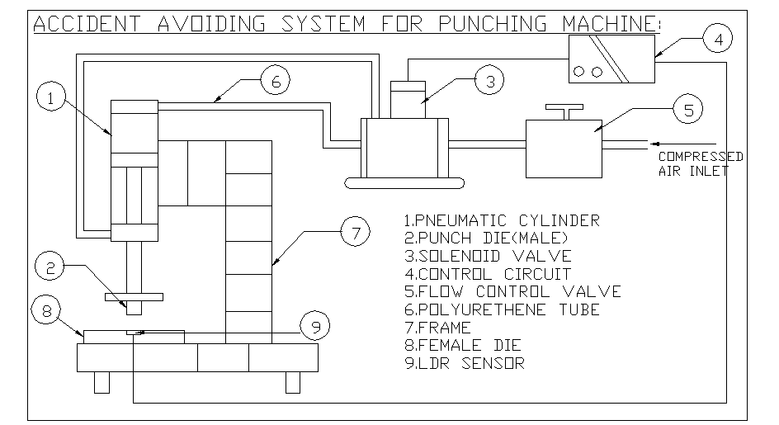
ADVANTAGES
- This system determines the accurate position than the manual method.
- This system reduces the accident time.
- This system eliminates the manual fatigue
- Highly accurate and more efficient.
- Compact and quick response.
DISADVANTAGES
1)The addition cost is un avoided because of control system

