RENEWABLE ENERGY TRAFFIC LIGHT
THROUGH SOLAR TRACKING SYSTEM
Introduction
Renewable energy house is operated under solar power with solar tracking system to achieved 99% solar efficiency in domestic home
Scope objective
The major purpose of solar tracking system is to gather maximum amount of power supply by means of tracking the solar panel. As soon as the system is switched on, the solar panel comes to the initial position, i.e. towards east.
Working principle
There are four LDR which is set each in 45º to keep tracking of the sun from sun rise to sun fall. As soon as the light falls on the first LDR, the signal will be sent to IC 89C51 microcontroller. This in turn controls the stepper motor position i.e. first quarter 0-45º.
As the sun rises when the sun light fall on the second LDR i.e. second quarter 45-90º, automatically first LDR is put off and the second one gets on. The signal from the second LDR goes to the IC and in turn goes to the stepper motor to change its position, i.e. 45-90^{o.} The same process goes on till the sun falls down. So we are able to track the sun continuously. The electric energy thus obtained from the solar cell goes to a storage cell / battery and it is stored. When this energy is needed it is obtained by using an inverter. It is also programmed, regarding the time of load on and load off. here load is traffic light with timer control unit
RENEWABLE ENERGY HOUSE
THROUGH SOLAR TRACKING SYSTEM

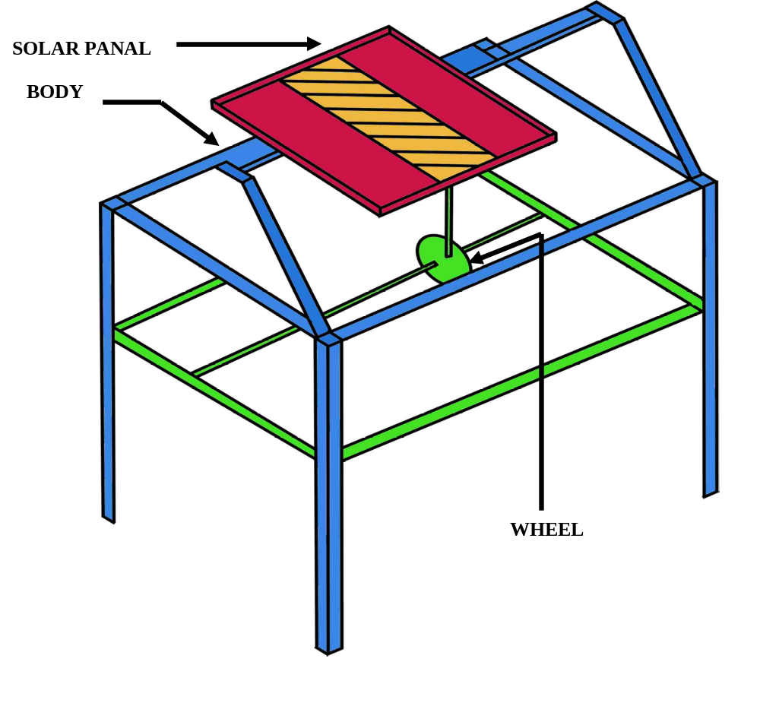

Advantage

- No need of electric power to operate
- No need of wiring
- It is a portable one

Disadvantage

- Little bit costly than conventional LIGHTING
- Operates up to the strength of battery

