ECWAY TECHNOLOGIES
IEEE PROJECTS & SOFTWARE DEVELOPMENTS
OUR OFFICES @ CHENNAI / TRICHY / KARUR / ERODE / MADURAI / SALEM / COIMBATORE
BANGALORE / HYDRABAD
CELL: +91 98949 17187, +91 875487 1111 / 2111 / 3111 / 4111 / 5111 / 6111 / 8111
VISIT: www.ecwaytechnologies.com | www.ecwayprojects.com
Mail to: ecwaytechnologies@gmail.com | ecwayembedded@gmail.com

CONVERSION OF SALTY WATER INTO PURE WATER BY SAFE WATER TECHNOLOGIES

Synopsis
Water everywhere is increasingly being contaminated from numerous sources and this, especially in drinking waters is a major concern, due to the associated health hazards.

The most common contaminants being suspended matter, mud, silt, algae, bacteria and other pathogens. Besides large bulk processing systems for industry, Safe Water in India also has special focus on small and medium water supply needs.

Solutions are offered for treatment of Municipal Waters, Surface Waters, Open and Tube Well Waters including source waters from streams, rivers, ponds and lakes for drinking water for Residences, Housing Colonies, Resorts, Villages, and Small Towns.

Today, more than 1.1 billion people lack access to safe drinking water and 2.6 billion people have no access to basic sanitation. In most industrialized countries, access to safe drinking water is nearly universal, and is often taken for granted.

This access has come as the result of massive public expenditures, though now more and more water supply agencies are being privatized.
In contrast, access is typically lower in developing countries, where economies are weaker, and infrastructure is not as developed.

The situation is the worst for the poorest people in developing countries, who often have no access to piped water supply. These families typically spend one fifth of their income on pure water.

In this paper I want to emphasize some Safe Water Treatment Technologies which is used in various house hold and Industries viz. Ultraviolet Water Treatment Systems, Specialty Potable and Non-Potable Water Treatment Systems ,

Conversion of salty water into pure water by Safe Water Technologies

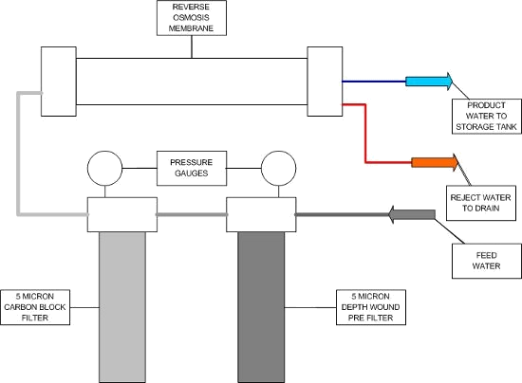

Advantages
- Better Life Series — patented filters and softeners with integrated UV
- Nitrate Removal Systems
- Tannin & Organic Removal Systems

Disadvantage
- Taste of the water differ from traditional water taste

