Online Real Estate Property Management

Main Planning of the Project:
- Find a new home, house
- Search real estate listing to buy.
- Search real estate listing to sell
- Search real estate listing to rent a house
- Search real estate listing for apartment, flat, plot
- Post home in real estate project
- User registration, Image upload
- Apartment, flat, plot, can post and search

Modules:
Administrator
- Add Country
- Add State
- Add City
- Add Location
- Add Budget
- Add Property
- Add Room
- Add Floor
- Add Currency
- Approval Image
- Approval Listing
- Approval Posting
- Post by users
- List by users
- List user
Listing
- Create List
- My Listing
- Initiate Response to Listing
Posting
- Create Post
- My Posting
- Initiate Response to Posting
Registration
- New Member
- Profile
- User Login
- Set User Role
- User Activation
- Forget Password
- My Listing Response
- My Posting Response
- Listing Response Receive
- Posting Response Receive
Advance Report
- Search by State
- Search by City
- Search by Property Type
- Search by Budget
- Search by Location
- Search by Bedroom
- Search by Floor

Project Flow:
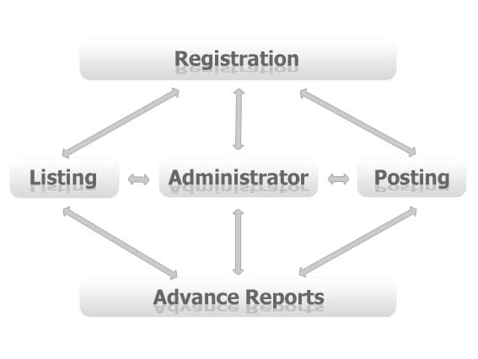

Software and Hardware Specifications
Hardware Specification
Processor : Pentium IV
RAM : 128 MB
Hard disk : 20 GB
FDD : 1.44MB
Monitor : 14 inch
Mouse : 3 Button scroll
CD Drive : 52 X
Keyboard : 108 keys
Software Specification
Operating System : Windows 2000/xp/2007
Languages : java 2(JDBC, JSP, Servlet)
Front End : HTML, JavaScript
Platform : J2EE
Web Servers : Web Logic8.1/Tomcat 5.0
Backend : My SQL

