Fabrication of Spark Plug Testing Machine

ABSTRACT

Introduction
Mechanical engineering without production and manufacturing is meaningless and inseparable. Production and manufacturing process deals with conversion of raw materials inputs to finished products as per required dimensions specifications and efficiently using recent technology
Scope and objective
In the conventional testers, the same condition prevailing in interval combustion engine is simulated and the performance of the spark plug’s are studied.

Working
In conventional tester there are three ranges given in the dial indicator of the pressure gauge. If the violet spark appears in the good condition. If is appear in the “Yellow” range, the spark plug is fair. If it appears in the no spark range the spark plug is poor and is to be discharged.

The project which is the modified version of the conventional method.

Initially the contact breaker point is in closed position. A 230 voltage electric current is supplied and it is stepped down to 12 voltages which only is compatible with the design of contact breaker point and it is primary winding.

Parallelly a motor is connected to a CAM. When the motor rotates the connected CAM also rotates. The CAM and the contact breaker point are connected together by an adjusting screw.

The motor and the rotates and so the electric current is supplied to the contact breaker point at that juncture the contact breaker point opens and the electric current passages on through winding and it is stepped up a transformer.

Now the 12 voltage is stepped up to 12000 voltages using a High tension coiled (Secondary winding). Now we could test the spark plug which is our ultimate objective.

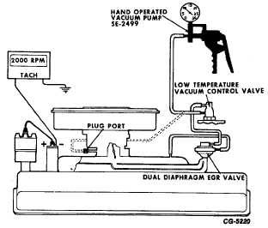

Expected outcome

- Simple Construction
- Less maintenance
- No need the compressor
- Less weight
- Low cost to compare the electrical spark plug.

APPLICATION
The following application are used to mechanical spark plug tester

- Automobile Industries
- Two wheeler work shop

Signature of the guide Signature of the HOD

